**The Battle of Neighbourhoods**

*Where would you like to open a Restaurant in New York?*

**Introduction/Business Problem:-**

Let’s say someone wants to open a New Restaurant in New York. What would be an ideal place for the same? The choice of place should consider availability of large customer base, major and prominent spots, other nearby restaurants and food shops, etc.

The target audience would be the businessmen who would like to open a restaurant in New York.

**Data Section:-**

Data for this analysis will be referred from:-

1. FourSquare API
2. NYU Spatial Data Repository

FourSquare API will be used to fetch information around nearby places like Restaurants, pub/bars, Shopping Complex, Cinema Hall, Nightlife spots, etc.

Whereas, NYU Spatial Data Repository will be used to fetch the neighbourhoods of the New York city. Data fetched from the repository includes the details like:-

1. Borough
2. Neighborhood
3. Latitude
4. Longitude

There are 5 distinct Boroughs and 306 Neighbourhoods in the data downloaded.

**Methodology:-**

In this project, we will try to determine the suitable place/area for opening a restaurant in New York.

In first step we have collected the required data of the major localities of New York. This data was fetched from NYU Spatial Data University Link**.**

Second step in our analysis will be to fetch the nearby venues around the 306 neighbourhoods (within 500 meter range according to Foursquare Categorization). The nearby venues will be of the following categories:-

1. Food (Category ID:- 4d4b7105d754a06374d81259)
2. Art and Entertainment (Category ID:- 4d4b7104d754a06370d81259)
3. Outdoors and Recreation (Category ID:- 4d4b7105d754a06377d81259)
4. Nightlife Spot (Category ID:- 4d4b7105d754a06376d81259)

In third and final step we will focus on:-

1. Borough which has the highest number of Venues meeting above mentioned 4 categories.
2. Neighbourhood under the Borough (fetched from above step).
3. Presenting map of all such locations and also create clusters (using K-means clustering) which can be used to determine the optimal venue by the stakeholders.

**Results:-**

Considering the factors like existing nearby restaurants, possibility of large customer base, recreational and relaxing spots, the most promising Borough to open a restaurant is **Manhattan**. Manhattan is followed by:-

1. Brooklyn
2. Queens
3. Bronx
4. Staten Island

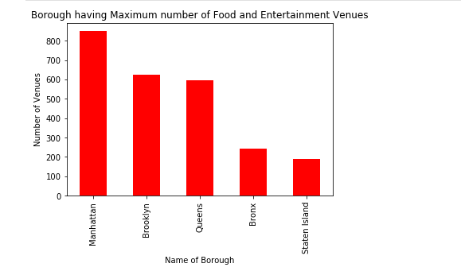

Now, in the Manhattan Borough, the most promising neighbourhood is **Murray Hill**. Murray Hill is followed by:-

1. East Village
2. Chinatown
3. Greenwich Village
4. Turtle Bay

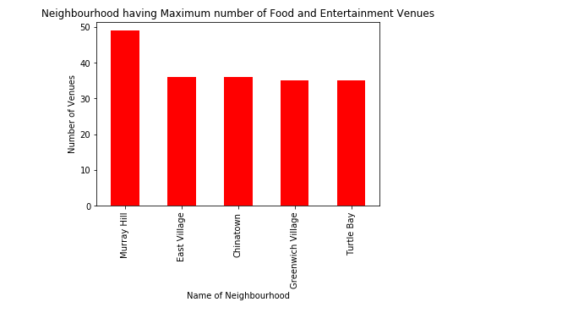

**New-York Map based on Clustering:-**

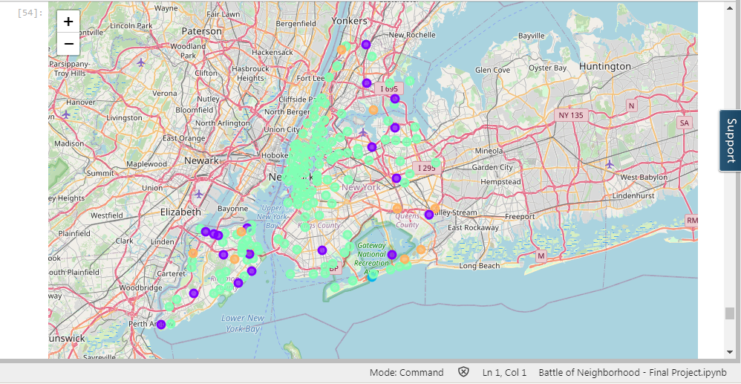

**Discussion:-**

All the above analysis and outcome was based on 2 factors:-

1. Existing restaurants and Food shops in the neighbourhoods.
2. Existing entertainment and recreational places, which attracts large customers.

However, there could be other factors as well, which might affect the optimum choice of opening a restaurant like:-

1. Real-Estate Availability
2. Prices
3. Neighbourhood/Nearby ambience
4. Accessible to public/private transport
5. Parking facilities

**Conclusion:-**

Purpose of this project was to identify a place to open a new restaurant in New York. By calculating restaurant density distribution from Foursquare data we have first identified general boroughs that justify further analysis (Manhattan), and then generated extensive collection of locations which satisfy some basic requirements regarding existing nearby restaurants. Clustering of those locations was then performed in order to create major zones of interest (containing greatest number of potential locations) and addresses of those zone centers were created to be used as starting points for final exploration by stakeholders.

Final decision on optimal restaurant location will be made by stakeholders based on specific characteristics of neighbourhoods and locations in every recommended zone, taking into consideration additional factors like attractiveness of each location (proximity to park or water), levels of noise / proximity to major roads, real estate availability, prices, social and economic dynamics of every neighbourhood etc.